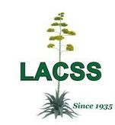
Los Angeles Cactus &
Succulent Society e New Member Form

Member Name(s):
Email:
Best Phone #:
Social Media:
How did you hear about us?

LACSS Newsletter the Cactus Chronicle & announcements are distributed via email

Dues paid Jan. 1 thought Aug. 31 cover all of the current year
Dues paid Sept. 1 through Dec. 31 cover the rest of the current year and all of the following year

Membership Dues: flat rate of $25 for up to two adults living in the same household.
Want a LACSS custom badge with your name? Add $10 per badge to total

For PayPal -- Go to lacactus.com, click Membership, include name, email address & cell phone number
Venmo, PayPal, cash and checks are payment options for in person payment at meetings.

